Week 5 Exercise

Talula Pontuti

02/21/2022

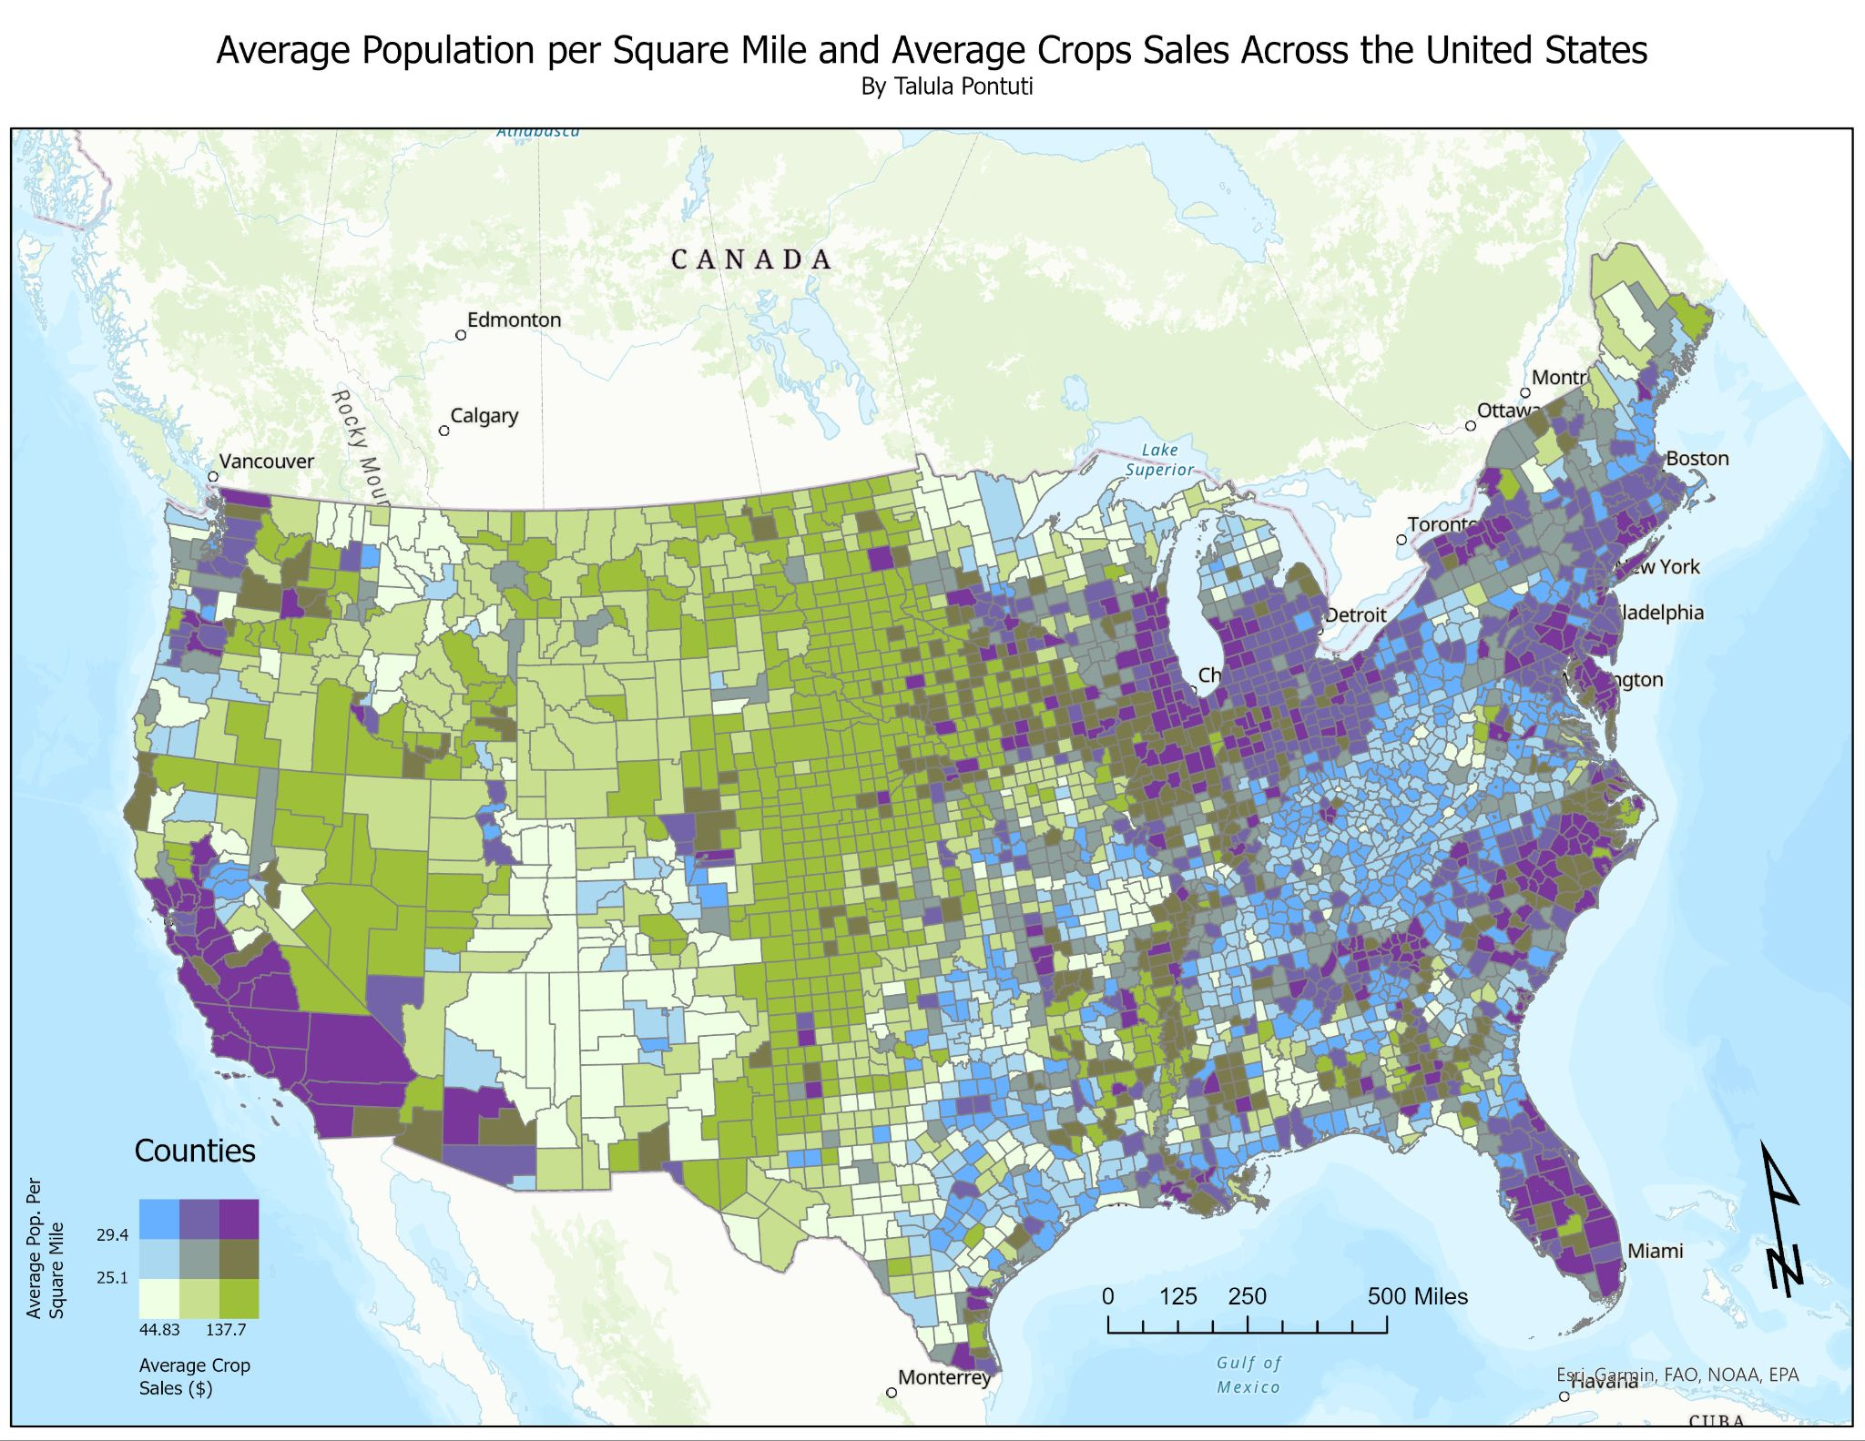

This map looks at average population per square mile and average crop sales. I was not exactly sure about the units since the data did not mention it, but I am assuming it is normalized in a logical way. Overall, these concentrations were not surprising. There are high values of both variables on the west coast, midwest, and along the east coast, where I assume there are more lucrative crops being grown, along with higher population density. The massive areas of green in the center of the United States seem reasonable since there is generally lower population density but nationally needed cash crops across the area.